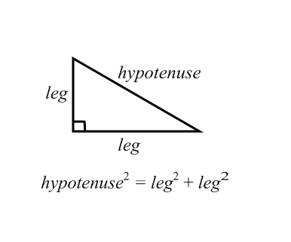
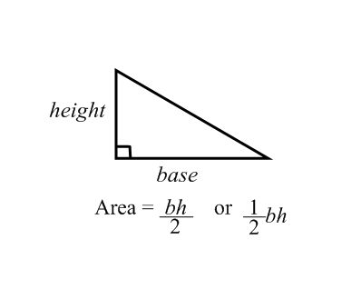
FORMULA SHEET

$a^{2 }$+ $b^{2}$ = $c^{2}$
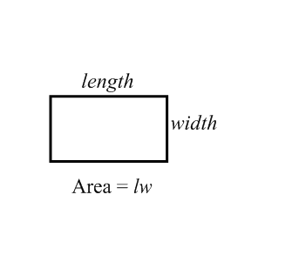
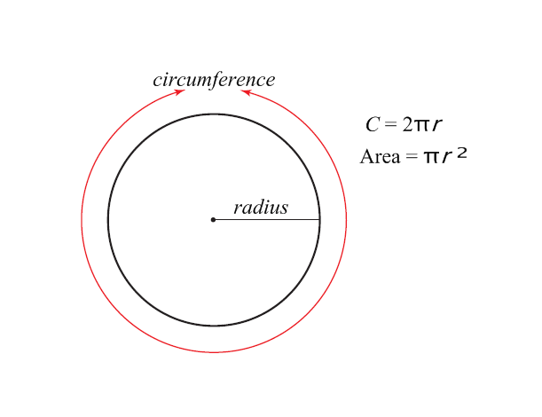

Volume of a cylinder Surface area of a cylinder
(area of base cm²) x (height cm) ($Area of lid=πr^{2}$ ) + ( $Area of base=πr^{2}$ ) +
($Area of base=πr^{2}$ ) x (height) = ____cm³ ($Area of middle=π(d)$ x (height) = ____cm²

